**Redis Local Installation Guide (Windows)**

This document provides step-by-step instructions to install and run Redis locally on a Windows machine.

## **Step 1: Download Redis for Windows**

* + Visit the following official Redis for Windows repository and download the latest release ZIP file:
  + 🔗 [https://github.com/redis-windows/redis-windows/releases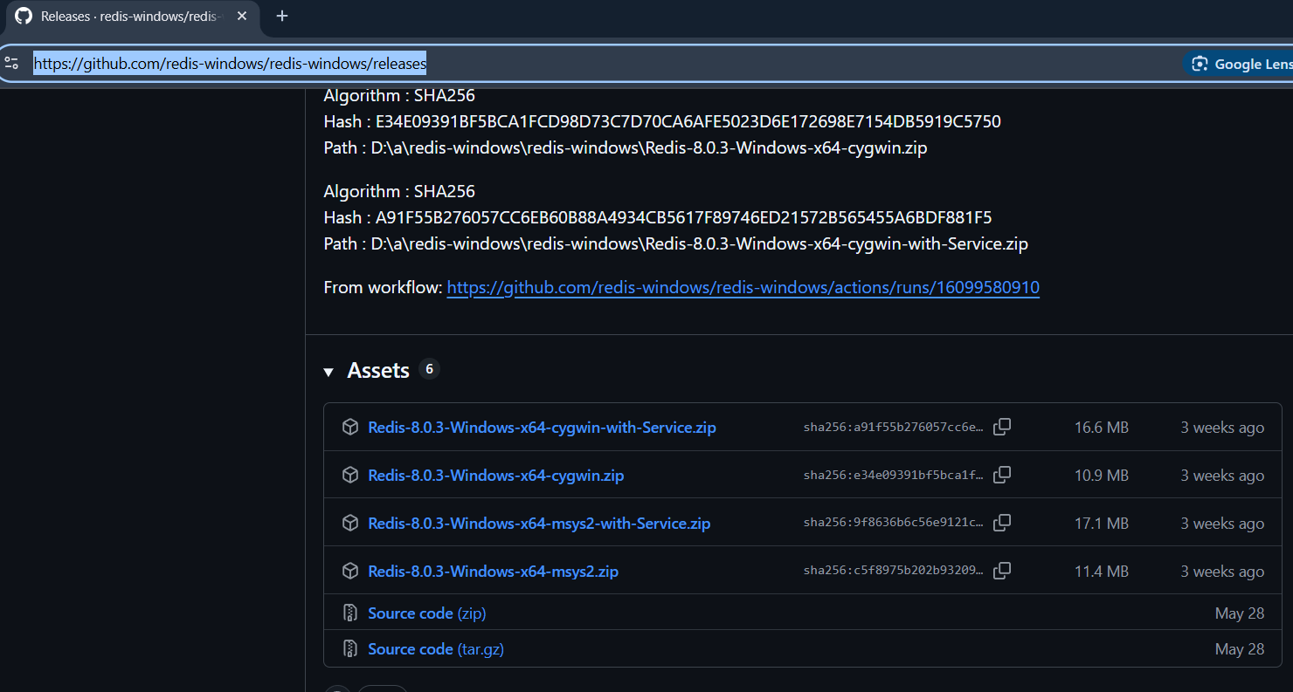](https://github.com/redis-windows/redis-windows/releases)

## **Step 2: Extract the ZIP File**

* + After downloading the ZIP file, extract its contents to a directory of your choice.

## **Step 3: Open Command Prompt in Redis Directory**

* + Navigate to the extracted folder, then open Command Prompt in that directory. You can do this by:
    - Typing cmd in the folder’s path bar.
      * 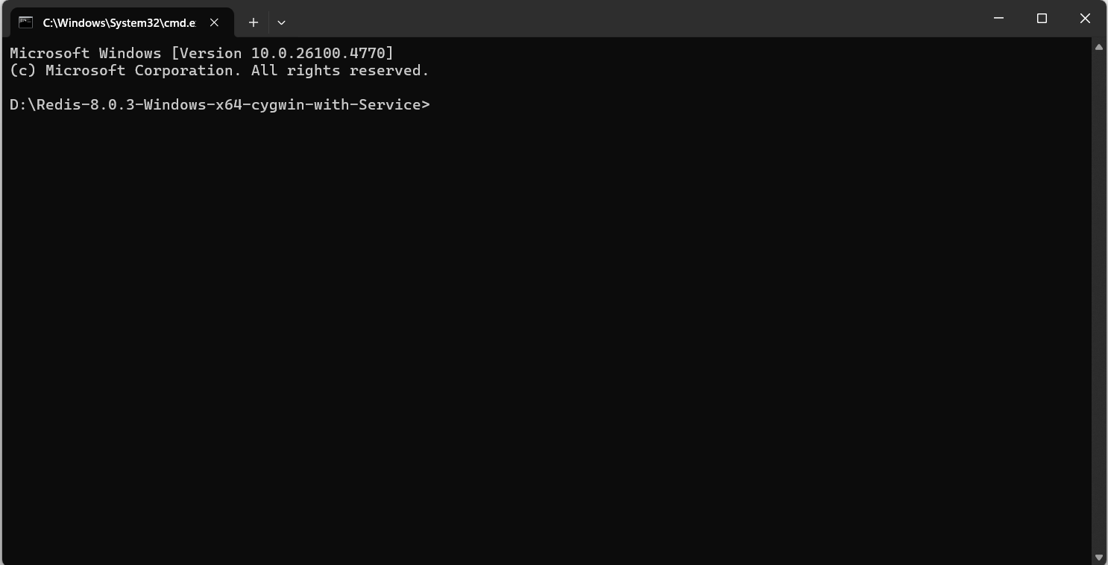
    - Or opening Command Prompt and navigating manually:
      * cd D:\Redis-8.0.3-Windows-x64-cygwin-with-Service\

## **Step 4: Start the Redis Server**

* + Run the Redis server executable by typing:
    - redis-server.exe  
      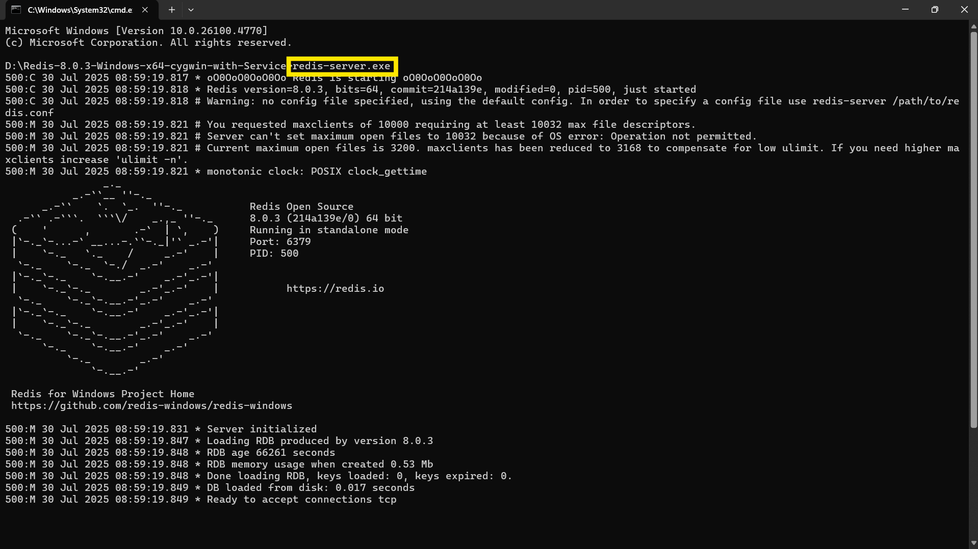
    - This will start the Redis server locally.

## **Step 5: Verify Redis is Running**

* + You can verify the server is working by opening another Command Prompt in the same directory and running:
    - redis-cli.exe
    - Then, test with the following command:
      * ping
      * You should receive the response: PONG  
        